ASSIGNMENT 19

Name : Akanksha Joshi

Roll No : B038

Batch : 3

Div : BTech CS B

--------------------------------------------------------------------------------------------------------------------------

Q.Write a Python program to accept a string 'accepted_string'. Generate a resultant string 'resultant_string' such that 'resultant_string' should contain all characters at the even position of 'accepted_string'(ignoring blank spaces).

Display 'resultant_string' in reverse order.

accepted_string: An apple a day keeps the doctor away

resultant_string: Aapedyepteotrwy

expected_output: ywrtoetpeydepaA

Hint: String starts from index 0, hence the starting character is at even position.

Source Code

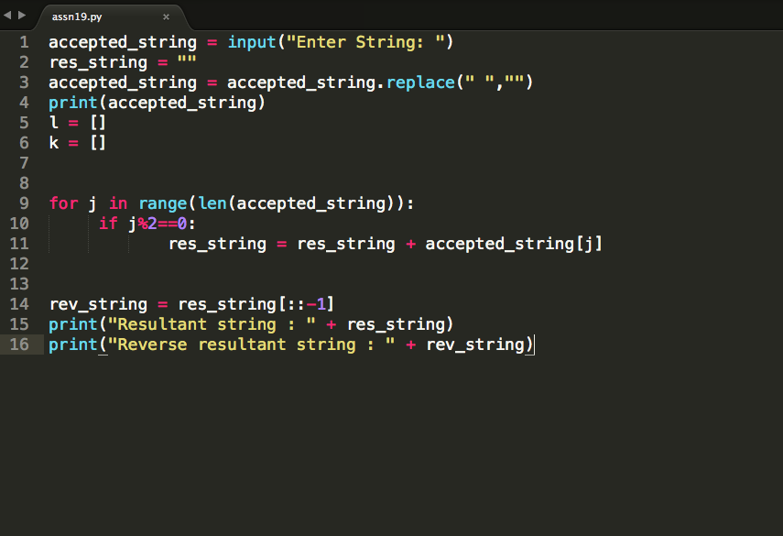

Output

Enter String: an apple a day keeps the doctor away

anappleadaykeepsthedoctoraway

Resultant string : aapedyepteotrwy

Reverse resultant string : ywrtoetpeydepaa